**Requirements Specification** **Deliverable**

**Software Requirements Specification (SRS)**

**1. Functional Requirements:**

1. User shall be able to login/signup
2. User shall be able to reset passwords via email verification.
3. User shall be able to update their profile
4. User shall be able to log out securely.
5. User shall be able to search for a job opportunity
6. User shall be able to apply filters for jobs
7. User shall be able to view job details
8. User shall be able to save a job opportunity
9. User shall be able to view saved job opportunities
10. User shall be able to apply to job opportunities
11. User shall be able to track employee status
12. User shall be able to edit job proposal
13. User shall be able to set reminders
14. User shall be able to receive notifications/messages
15. User shall be able to reply to messages
16. Companies shall be able to login/signup
17. Companies shall be able to update their profile
18. Companies shall be able to reset passwords via email verification.
19. Companies shall be able to add job opportunities
20. Companies shall be able to edit job opportunities
21. Companies shall be able to delete job opportunities
22. Companies shall be able to mark job as closed
23. Companies shall be able to receive job proposals
24. Companies shall be able to mark proposal as reviewed
25. Companies shall be able to reject job proposals
26. Companies shall be able to schedule interviews for applicants
27. Companies shall be able to send offer to applicants

**2. Use Case:**

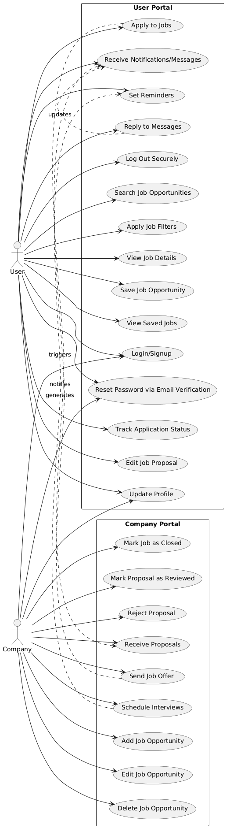

**3. Non-Functional Requirements:**

- Performance: Load job listings in <2 seconds.

- Usability: Intuitive UI with onboarding tutorials.

- Reliability: Data persistence during offline use.

- Security: Encrypt sensitive user data (e.g., notes).

**4. System Constraints:**

- Limited to mobile native-platforms (Android).

- Dependent on third-party job APIs (rate limits/data availability).

- Dependent on Companies offering jobs.

**5. Assumptions and Dependencies:**

**System Assumptions**

* Users and companies will authenticate via unique email addresses.
* A stable internet connection is required for full functionality.
* Job postings and applications will be processed in real-time.
* Notifications will be sent via email and in-app messaging.
* Security measures (e.g., encryption, authentication) will protect user data.
* The system will scale to accommodate growth in users and job listings.
* External integrations (e.g., email, calendar) may be used for interviews and offers.

**System Dependencies**

* **Database** – Stores user data, job listings, and applications.
* **Authentication Service** – Manages secure logins (e.g., OAuth, JWT).
* **Email Service** – Handles verification and notifications.
* **Hosting & Cloud Storage** – Supports scalability and file storage.
* **Front-end & Back-end Frameworks** – Provides a responsive UI and API handling.
* **Search & Filtering Service** – Optimizes job search and recommendations.
* **Messaging & Notifications** – Enables real-time communication.
* **Security & Encryption** – Ensures safe data transmission and storage.
* **Logging & Monitoring** – Tracks system performance and errors.